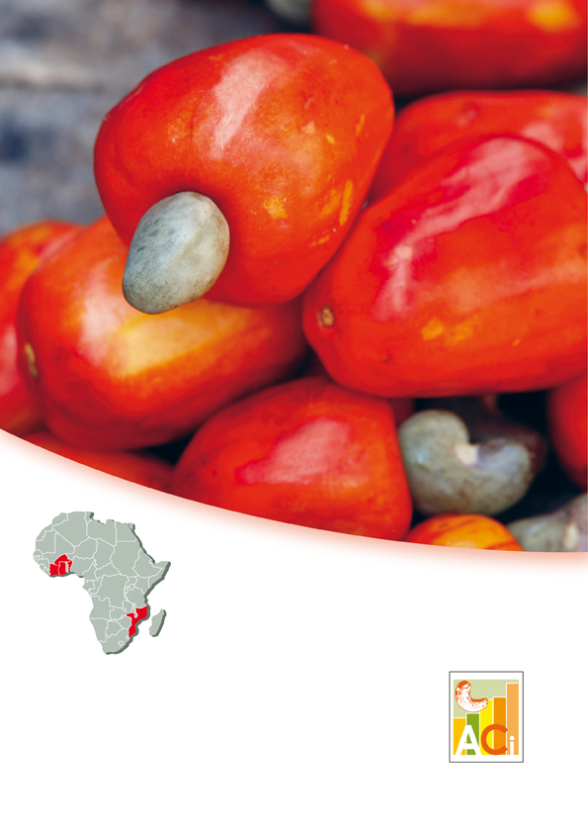**f**



**Concept Note for the Master Trainer Program for Promotion of Cashew Value Chain in Africa**

**Editions 7, 8, 9**

**Competitive Cashew initiative and the African Cashew Alliance**

**September, 2018**

**Summary**

1. Background 4

2. Achievements so far 4

3. Who can become a Master Trainer? 5

4. The Program 6

5 Master Trainer Skills 7

6 Expectations of Master Trainers 8

7 Graduation 8

8 Who and Where? 8

9 Costs and Contributions 8

10 Timeline 8

11 Participant Selection 9

12 Application documents 9

13 Submission of Applications 9

14 About ComCashew 10

Competitive Cashew initiative is funded by:

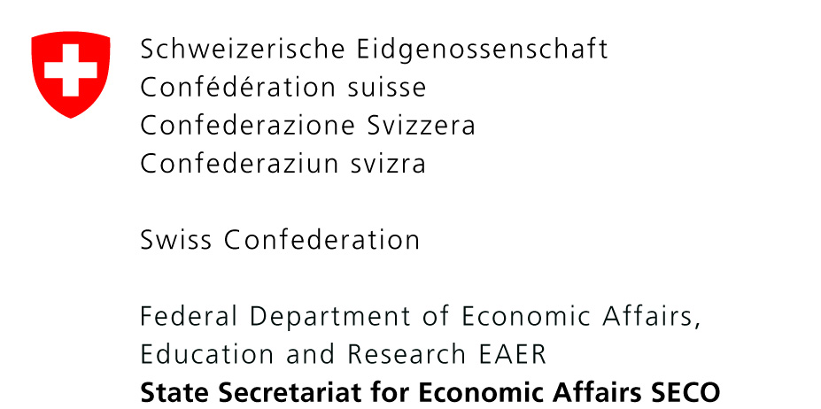 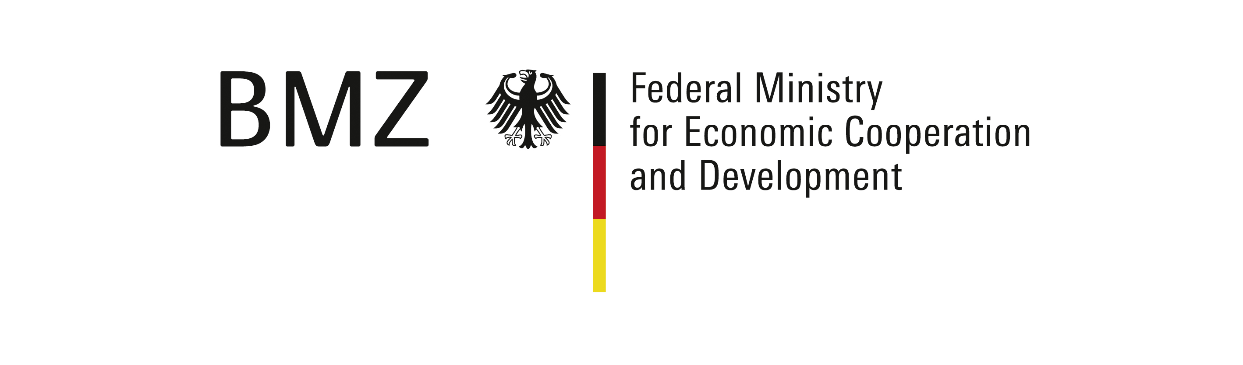

Implemented by:

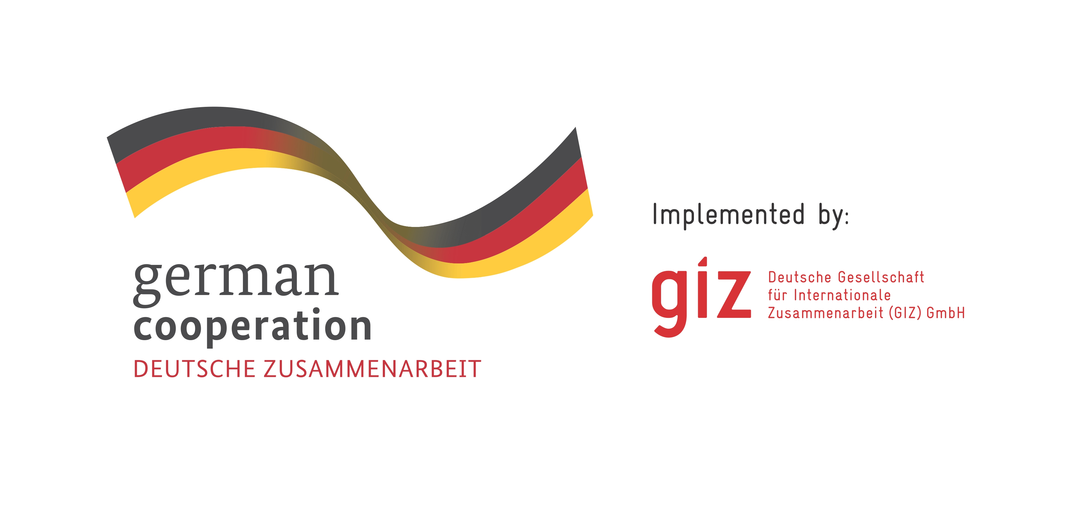

In cooperation with:

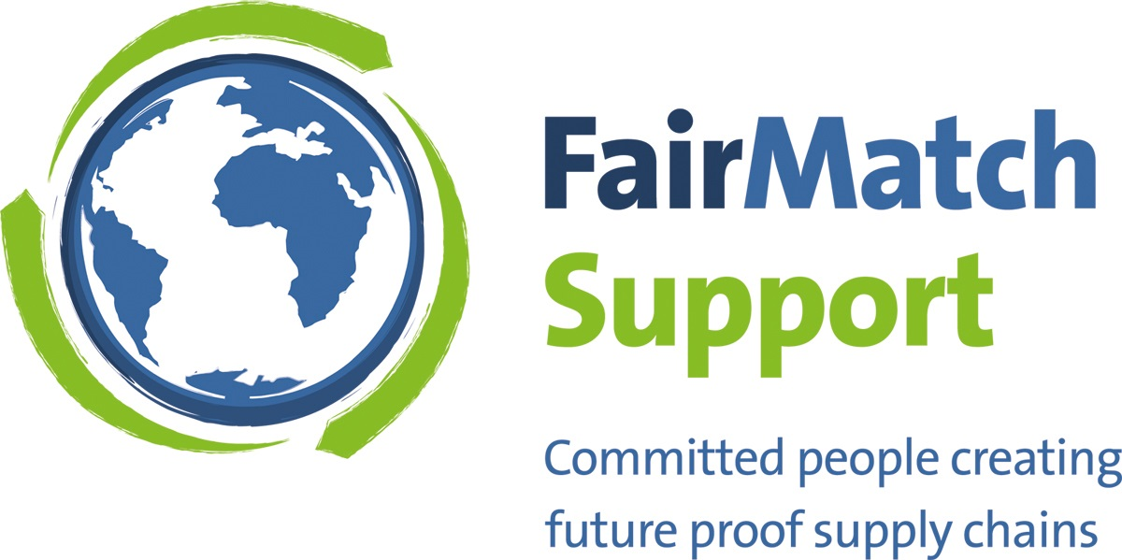



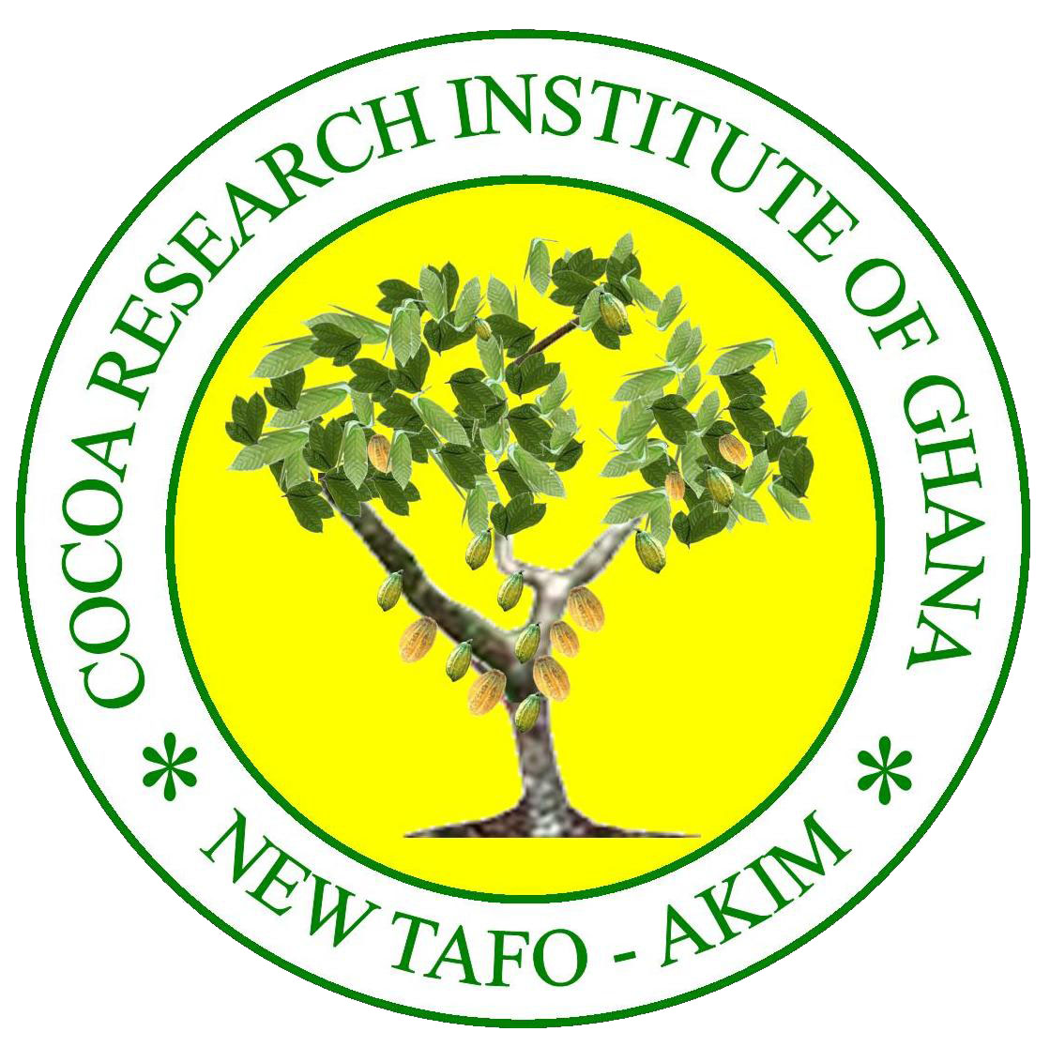



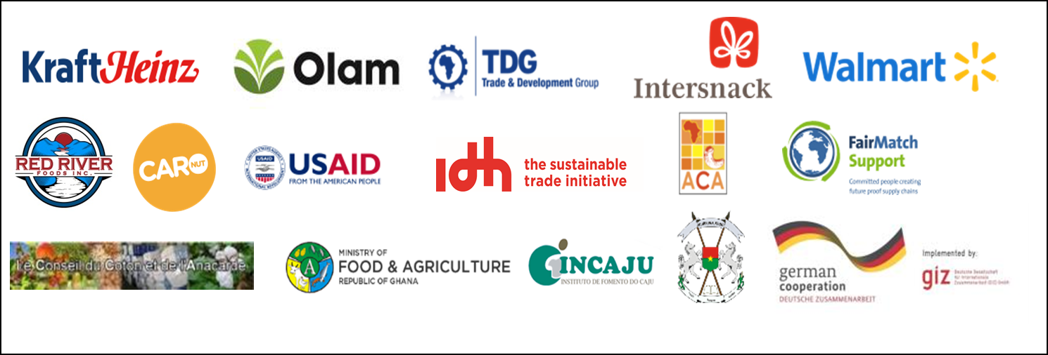

# Background

The Competitive Cashew initiative (ComCashew) aims at strengthening the competitiveness of African Cashew production to reduce poverty amongst small-scale farmers in the six project countries-Benin, Burkina Faso, Côte d’Ivoire, Ghana, Mozambique and Sierra Leone. ComCashew started in 2009 and is currently in its third phase, which will run until December 2020.

The long term vision of the MTP is to build a pool of technical and managerial expertise, to facilitate regional exchange between cashew experts by sharing lessons learnt and innovations at regional and national level. In each country, there is resource persons for knowledge transfer in the following areas:

* Agronomy and cashew orchards management;
* Post-harvest management and quality of cashew products;
* Processing and value addition to cashew and -its by-products;
* Market Mechanism, nut and kernel market analysis;
* Business relationships between stakeholders;
* Value chain development;
* Economics of cashew farming and processing
* Self-financing advice;
* Price analysis and price formation;
* Design and production of teaching/training materials.

Activities of Phase 3 are organised around four objectives to achieve project objectives:

* **Production:**

Increasing the productivity of cashew farmers.

* **Processing:**

Creating a local processing industry that is globally competitive.

* **Supply Chain Linkages:**

Establishing stable and long-term business relationships between producer groups, processing units and buyers.

* **Sector Organisation:**

Key stakeholders are organised at the national level with common goals, the processing industry is effectively represented.

In its third phase, the project wants to consolidate the achievements, reinforce the capacity of local actors, and transfer knowledge to partners and target groups. In this context ComCashew upscales the “Master Training Program” (MTP) or “*Programme de Maître Formateur*” in French. The program aims at creating a pool of qualified experts in the cashew value chain to facilitate knowledge exchange, learning and innovation within the cashew sector in West Africa.

Due to the high interest and demand from our partners and cashew stakeholders shown with over 250 applications received for a target of 75 participants during the previous editions, ComCashew has decided to launch two editions in 2018.

The on-going editions 5 and 6 will end in November 2018.

In 2019, ComCashew aims to organize 3 editions to respond to the consistently increasing demand. This is always in collaboration with national institutions in countries.

# Achievements so far

* 1. **Experts trained**

Started in 2013, the Programme is today in its sixth edition. The on-going editions 5 and 6 have **165 participants.**

After 4 editions of MTP **291** experts along the cashew value chain among which **78** women were trained.

The programme gathers in a single entity all the actors of the value chain: farmers, Processors, Traders and Exporters, Ministries, Universities, Research, Finance …

* 1. **Regional exchange**

The MTP constitute an effective regional exchange between **16 countries: Benin, Burkina Faso, Côte d’Ivoire, Ghana, Mozambique, Sierra Leone, Togo, Mali, Gambia, Cameroun, Tanzania, Zambia, Chad, Nigeria, Senegal and Kenya.**

*MTP participants’ countries, GIZ/ComCashew*

Participants from ComCashew project countries

Participants from Others African countries

* 1. **Collaboration amongst partners**

The Master Training Program was set up and jointly organised and financed by ComCashew and its partners such as the GIZ, ACA, the Ministry of Food and Agriculture and Cocoa Research Institute Ghana, the Ivorian Cotton and Cashew Council, and Fairmatch Support.

Past sessions were also co-sponsored by:

State Secretariat for Economic Affairs (SECO), PSAC, The Zambian Ministry for Agriculture and the African Development Bank, World bank / PACA, IRD, BMZ/GIZ bilateral projects in Togo, Burkina Faso, and Cameroon, Caju Industrie, Burkina Cajou, The Ministry of Agriculture in Burkina Faso, Ministry of Agriculture and Cashew Board in Tanzania, The Ministry of Agriculture and COOPI in Sierra Leone, USIBRAS et INCAJU.

* 1. **Testimonies from Master Trainers**

‘’It is thanks to my MTP certificate that I got promoted as cashew processing technician. The way I analyze and take decisions have changed in a positive manner. I am more focused and always check my assumptions’’.

***Amy Fall, Senegal, Master Trainer, Edition 1***

“With the knowledge gained with the MTP, I put in place a nursery in my village in order to help the population in cashew production. I am now a reference in cashew production in my village’’**. *Samuel Essandoh, Ghana, Master Trainer, Edition 2***

“Thanks to the MTP, I am more attentive to my professional environment as well as my life. My ability to anticipate actions has increased a lot. My way of expressing my points of view is more relevant and persuasive’’.

***Adou Kouakou Mathias, Côte d’Ivoire, Master Trainer, Edition 2***

“The MTP is different from the other trainings I took part in by the heterogeneity of the audience (Farmers; Processors; Traders; and Researchers)”

***Traoré Zambinya Nathalie, Burkina Faso Master, Trainer, Edition 3***

# Who can become a Master Trainer?

The 2019 Master Training Program editions’ targets 75 participants and 5 resources persons per edition working in the private and public sectors as well as in NGOs promoting the cashew value chain in West Africa. The applicants must be mandated by their host institution. Applications will go through a transparent selection process in line with fixed criteria.

* 1. **Applicants**

Applicants for the Master Trainer Program are experienced consultants or experts on training/advising along the cashew value chain or any other crop, staff of processing companies (start-ups as well as already installed units) and consultants working in cashew. They are employees coming from private and public institutions.

* 1. **Entry requirements**

To be an eligible candidate for the Master Trainer Program, applicants must meet these requirements:

* A higher education degree in the field of agriculture, agricultural economics, economics, marketing, agro-food, food science and technology and other related subjects in agricultural value chains;
* Knowledgeable of agricultural value chains in general and cashew in particular;
* Experienced in training farmers/processors/ trainers, supervising training activities, staff of a processing unit, Government adviser, researcher or any subject related to cashew and or other crops
* Employed by an organisation/institution/ company with activities associated to the promotion of cashew (private, public or NGO) or an independent consultant providing capacity building to stakeholders.
* Endorsed by the host institution/company to apply to become a Master Trainer in cashew.
* Be a national in Benin, Burkina Faso, Ghana or Côte d’Ivoire. However, the program allows a certain number of participants from other African cashew-producing countries as well.
  1. **Which organisations/institutions may applicants be affiliated to in order to join the program?**

The program targets private and public sector as well as NGO candidates from:

* Agricultural extension organisations;
* Non-governmental organisations providing outreach, extension or research and development;
* Cashew farmer organisations;
* Processing factories
* Consulting organisations and NGOs in

processor training

* Research and Development Institutions;
* Inter-Professional organisations or

associations;

* Individual independent consultants and consulting firms;
* Projects and development programs.

# The Program

The MTP covers a period of 7-8 months. The program includes three one-week class-room sessions, offering a facilitated platform for exchange. Each session focuses on a specific set of modules. **Participation is obligatory in all three sessions to complete the program.**

Between the class-room sessions, so-called inter-sessions or field activities of maximum three months are scheduled. During the intersession programs, participants return to their host institutions, share their knowledge with colleagues and do hands-on work in the field to apply what they have learned in the training sessions.

Linking theoretical knowledge to practice, the MTP technical modules and activities are aligned with the production, processing and marketing.

**4.1 Session 1: Organization of the cashew market and implementing instruments for a Master Trainer**

The learning objective of Session 1 is to become aware of the cashew value chain concept, the dynamics of the cashew market and the development of training material. The first session is composed of three modules:

* **Value chain development and cashew market:**

Overview on value links concept (value chain selection, actor mapping, value chain diagnosis, approach for cashew promotion, cashew market (importance & trend, nuts and kernels trade, market period, traceability, bulk-selling, social and economic issues, quality, standard, food safety, fair trade and organic market)).

* **Training materials development:**

Review of various teaching materials, targeted audiences, appropriate teaching tools and design of educational materials

* **Trainer’s attitudes:**

Attitude of a trainer and use of training tools and pedagogic technics.

* 1. **Session 2: Planting material development and good agricultural practices**

The learning objective of Session 2 is to understand the mains steps for good improved planting material development, the importance of good agricultural practices (GAP) and their implication on productivity. This session is structured in two modules:

* **Improved planting material development:**

High yield tree selection, grafting, nursery establishment and management, orchards establishment and maintenance, economic analysis of nurseries and cashew orchards.

* **Good agricultural practices (GAP) and harvest & post-harvest:**

Orchards maintenance (cleaning, pruning, fire-break, intercropping), rehabilitation and top-working of orchards, pest and disease management, conditions for harvesting, cleaning, drying, packaging, storage, and nut quality measurement, (KOR).

* 1. **Session 3: Cashew processing, sector organisation and cross-cutting issues**

The learning objective of Session 3 is to learn about value addition though cashew processing, the benefits of a better organized sector for various stakeholders, the roles they play as well as cross-cutting impacts on cashew industry. The session is composed of 3 modules:

* **Cashew nuts and by-product processing:**

Nut processing including processes, products, factory/ unit establishment, food safety, management and governance etc., by-products processing, marketing and economics of processing.

* **Organization of the cashew sector:** Governance of the cashew sector, policies, actor mapping and role distribution, best practices across countries and value chains.
* **Cross-cutting issues:**

Financing in the cashew sector, gender, nutrition, climate change, alternative and innovative tools for disseminating information and collecting data, rural radio programs to promote value chain and best practices.

* 1. **Activities during inter-sessions**

The inter-sessions are the periods between the class-room sessions. Each inter-session is about 2-3 months. During this period, participants carry out practical activities to develop and deepen their knowledge attained on the technical sessions. Participants:

* Work with producer groups to collect data on cashew production;
* Document the best practices for cashew production at the farmer level;
* Prepare case studies to share with other Master Trainers during the next technical session;
* Collect information on cashew
* Train farmers, processors, extension practitioners, and other targets actors of their choice
* Document the effectiveness of extension for cashew production, processing and marketing.

During the next technical session, participants share their experiences and results in peer review groups.

# Master Trainer Skills

After completion of the Master Training Program, each participant is recognized as:

* Resource-person with knowledge in cashew production, processing, marketing, economics, and organization of the cashew sector;
* A qualified expert in the field of training of trainers in cashew;
* An expert in the design and development of training programs for specific target groups;
* A reference person who is well connected at national and regional level within the cashew value chain;
* An expert in the design, adaptation and updating of educational/training tools.

The Master Training Program is designed to provide learning and training support related to cashew. However, the acquired skills and knowledge are also applicable to other crops and agricultural value chains.

# Expectations of Master Trainers

At the end of the training, the qualified Master Trainers are expected to provide technical trainings to other trainers (training of trainers) as well as farmers and other actors of the supply chain and also advise and provide guidance for the growth of the cashew sector

As such, they must ensure:

* The design, updates and production of learning materials according to new developments in the cashew sector;
* The transfer of knowledge by conducting training of trainers and extension;
* The selection and supervision of cashew sector actors (for example farmers, processors, and government officials) for data collection to inform the sector;
* Contributions to workshops/meetings on learning and innovation.

# Graduation

After completing the training program, the Master Trainer will be recognized as a reference person. He/she shall multiply that knowledge by exchanging with other sector partners/actors. For a candidate to successfully complete the program, all efforts during the three technical sessions and the two inter-sessions are taken into account. The final evaluation and graduation takes place after the third session.

# Who and Where?

The training is conducted in Ghana, Côte d’Ivoire and Benin by the Competitive Cashew initiative with expert support from GIZ, FairMatch Support, the African Cashew Alliance and other national institutions and companies involved in the cashew sector. The working languages will be English and French (with translation service).

# Costs and Contributions

Participants or their institutions are required to pay a contributing fee of EURO 3.000 for the 3 sessions. This includes:

* Training fees;
* Food and accommodation;
* Lump sum for transportation within the country of training.

Only upon request, there are a **limited number** of **sponsorships** from ComCashew for the following countries only: **Benin, Burkina Faso, Côte d´Ivoire, Ghana, Mozambique and Sierra Leone**.

During intersessions, the candidates’ (sponsored or non- sponsored) home institutions will be in charge of all expenses. These include:

* Field activities related on data collection, monitoring, documentation of farm analysis
* Travel / transportation costs
* Accommodation / food during field activities related
* Salaries of participants during the training sessions.

# Timeline

|  |  |  |  |
| --- | --- | --- | --- |
| Date (2019) | Session 1 | Session 2 | Session 3 |
| Edition 7 | **March**: 25th -29th | **June**: 24th – 28th | **September**: 23rd – 27th |
| Edition 8 | **April**: 29th April – 3rd May | **July**: 29th – 2nd August | **October**: 28th - 1st November |
| Edition 9 | **May**: 27th – 31st | **August**: 26th – 30th | **November**: 25th – 29th |

# Participant Selection

* **28th September 2018:**

Call for application opened;

* **31st December 2018:**

Deadline for application submission;

* **04th February 2019:**

Sending notification to selected participants of each edition.

# Application documents

* A letter of motivation; and potentially request for sponsorship
* A completed application form, signed by the applicant and approved by the responsible head of institution or deputy in the applicant’s host organisation
* A reference person (surname, first name, and contact information.

Shortlisted candidates will be required to provide the following evidence:

* Copies of qualifications/ certificates/ diplomas;
* Copy providing a proof of skills related to the cashew industry.

# Submission of Applications

The application must be sent to the Competitive Cashew initiative (ComCashew) by mail to:

**Cynthia Benon**

E-mail: [al-da.benon@giz.de](mailto:al-da.benon@giz.de)

And

**Viviane Alima M’Boutiki**

E-mail: alima.mboutiki@giz.de

# About ComCashew

The Competitive Cashew initiative (ComCashew) presents a new and innovative model of broad-based

multi‐stakeholder partnership in development cooperation. ComCashew is mainly funded by the German Federal Ministry for Economic Cooperation and Development (BMZ). Private and public companies are also contributing in cash and in kind. These are: FairMatch Support, African Cashew Alliance (ACA), Trade and Development Group, Intersnack, KraftHeinz, Olam, Red River Foods, CARO Nuts, Ministry of Food and Agriculture of the Republic of Ghana (MoFA), the Conseil Coton Anacarde Côte d´Ivoire (CCA), Sustainable Trade Initiative (IDH), United States Agency for International Development (USAID), State Secretariat for Economic Affairs (SECO), INCAJU Mozambique, Walmart, Direction Générale de la Promotion de l‘Economie Rurale, Burkina Faso (DGPER).

ComCashew’s main objective is to increase the competitiveness of Cashew Smallholders, Processors and other actors in the value chain and achieve a lasting reduction of poverty in the project countries, namely Benin, Burkina Faso, Côte d’Ivoire, Ghana, Mozambique and Sierra Leone. Beyond farmers’ direct income impact, increasing cashew processing capacity in Africa, the development of sustainable supply chain linkages and supporting a better organisation and coordination of the cashew sector, are integrated in the project. ComCashew, its partners and Deutsche Gesellschaft für Internationale Zusammenarbeit GmbH (German International Cooperation) provide training on technical issues as well as business advice for and facilitate linkages between farmers and processors. ComCashew strengthens initiatives in the cashew sector and responds to questions regarding investment and processing.